ECA5701-NANOELECTRONICS
Saambavi U
192512099
CO1
EXPERIMENT 3
Simulation of Energy States of Quantum Dot using NanoHub

Case Study 1: Simulate the energy states of cylindrical quantum dots of X=15 nm, Y = 10.5nm and Z = 8 nm.
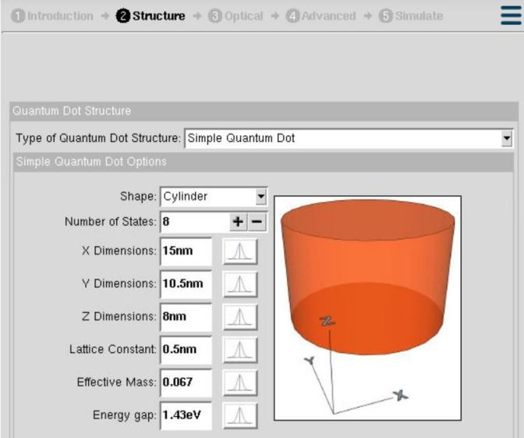
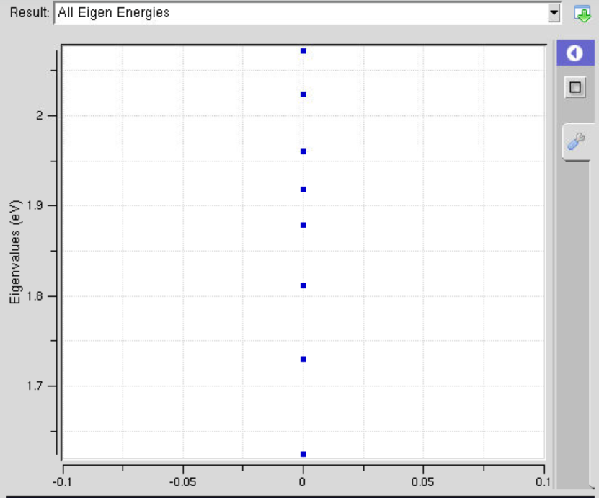
Case Study 2: Simulate the energy states of two-layer cuboid quantum dots
